Project Design Phase-I
Solution Architecture

Date | 19 September 2026
Team ID
Project Name | EV Market Performance and Insights
Maximum Marks | 4 Marks

Solution Architecture:
Solution architecture is a complex process – with many sub-processes – that bridges the gap between business problems and technology solutions. Its goals are to:
- Find the best tech solution to solve existing business problems.
- Describe the structure, characteristics, behavior, and other aspects of the software to project stakeholders.
- Define features, development phases, and solution requirements.
- Provide specifications according to which the solution is defined, managed, and delivered.

Solution Architecture Diagram:
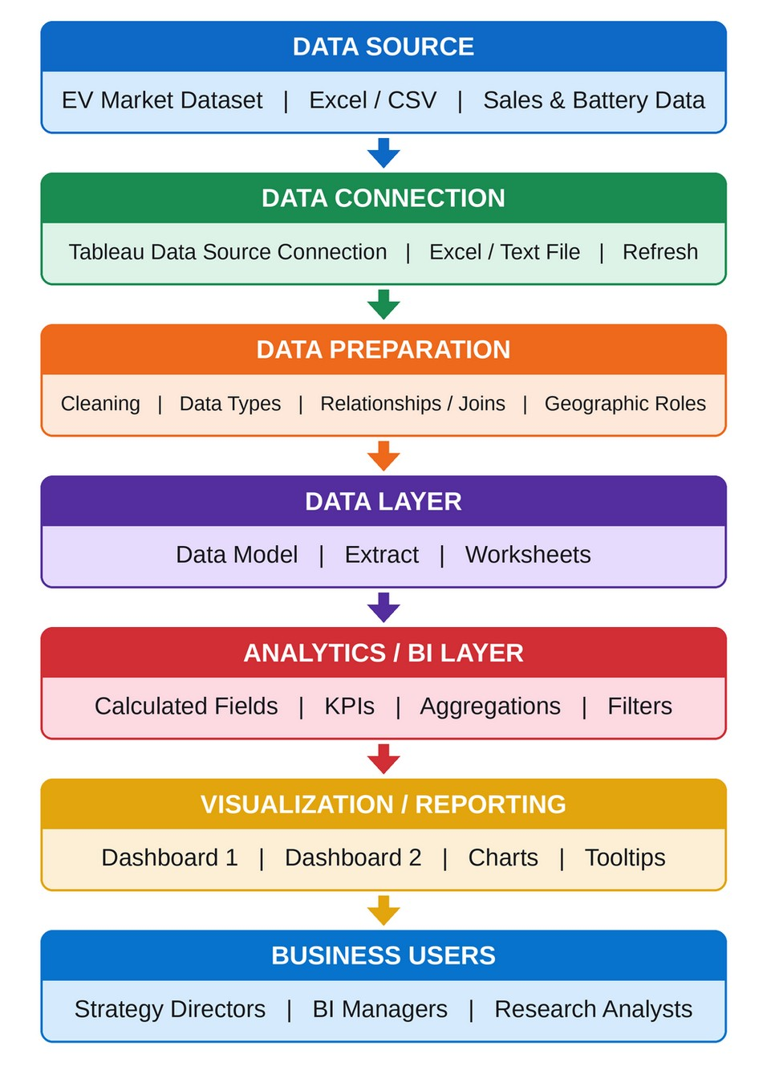

Component Description Table
Component Name | Description / Role in Architecture | Technology Used
Data Source | The EV market dataset that holds vehicle sales, price, battery, range, charging, manufacturer, country, rating and CO2 information. | Excel / CSV file
Data Connection | Connects Tableau to the dataset and lets the data be refreshed when the source file changes. | Tableau Desktop data source connection
Data Preparation | Cleans the data, sets data types, relates tables and assigns geographic roles for country and region fields. | Tableau Data Source tab
Data Layer | Stores the prepared data model and extract that every worksheet and dashboard reads from. | Tableau data model / extract
Analytics / BI Layer | Calculates KPIs and measures such as total sales, average price, average range, CO2 saved, retained value and efficiency, and applies filters and aggregations. | Tableau calculated fields and LOD expressions
Visualization / Reporting | Presents the insights as charts in two interactive dashboards with a shared category legend, filters and tooltips. | Tableau Desktop (Dashboard 1 and Dashboard 2)
Business Users | Strategy directors, BI managers and researchers explore the dashboards to compare segments, manufacturers and technologies and to make decisions. | Tableau dashboards (Tableau Public / browser)

